**Task 2. Create a DynamoDB Table:**

* 1. **Create a new DynamoDB table with a primary key of your choice.**
  2. **Define the provisioned throughput for the table.**
  3. **Run CRUD operation in the in DB table using Queries.**

**Creating DynamoDB table with a primary key using AWS CloudShell:**

1. Open the Aws CloudShell and in the CloudShell run the following query

**aws dynamodb create-table \**

**--table-name MyProductsTable \**

**--attribute-definitions AttributeName=ProductID,AttributeType=N \**

**--key-schema AttributeName=ProductID,KeyType=HASH \**

**--provisioned-throughput ReadCapacityUnits=5,WriteCapacityUnits=5**

this will create a DynamoDB table named “MyProductsTable” with a primary key attribute "ProductID" of type Number. Also with this query provisioned throughput is defined for the table.

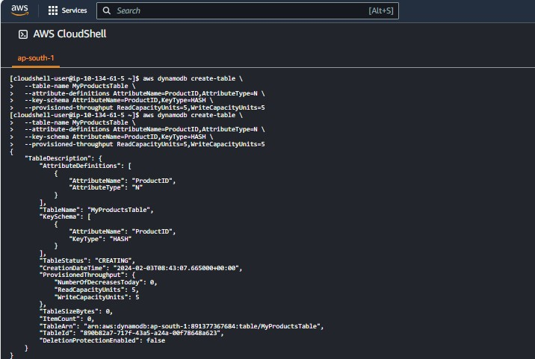

The table is created successfully.

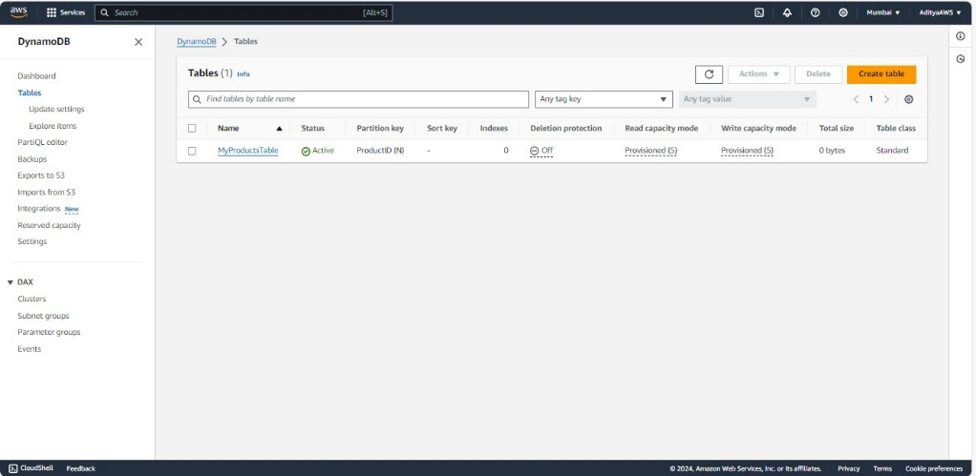

1. Now, Inserting data in the table run the below queries:

**aws dynamodb put-item \**

**--table-name MyProductsTable \**

**--item '{"ProductID": {"N": "101"}, "ProductName": {"S": "Laptop"}, "Price": {"N": "1200"}}'**

This command will insert an item with ProductID=101, ProductName="Laptop", and Price=1200

**aws dynamodb put-item \**

**--table-name MyProductsTable \**

**--item '{"ProductID": {"N": "102"}, "ProductName": {"S": "Smartphone"}, "Price": {"N": "800"}}'**

This command will insert an item with ProductID=102, ProductName="Smaertphone", and Price=800

C:\Users\promact.DESKTOP-L6Q2MV5\AppData\Local\Packages\Microsoft.Windows.Photos_8wekyb3d8bbwe\TempState\ShareServiceTempFolder\Screenshot 2024-02-03 163847.jpeg

Result:

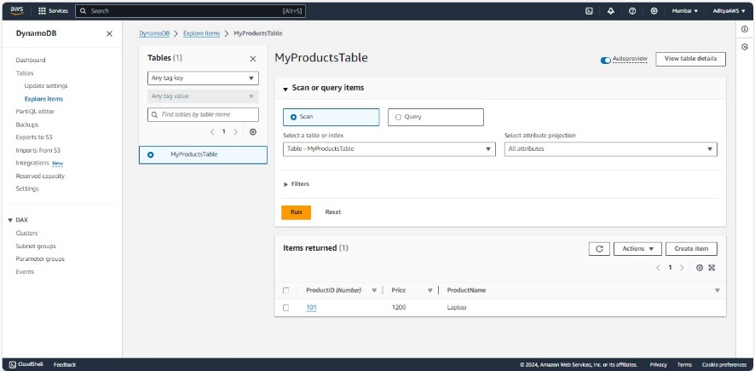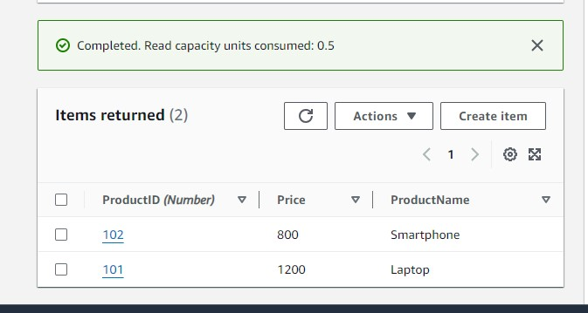

1. Now, reading the item in the table. Run the below query

**aws dynamodb get-item \**

**--table-name MyProductsTable \**

**--key '{"ProductID": {"N": "101"}}'**

This will give the detail of item with ProductID = 101.

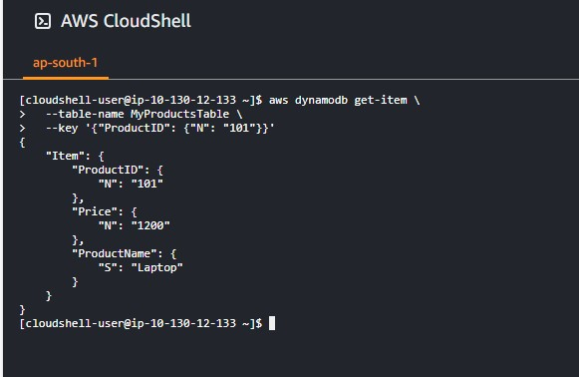

1. Updating the item detail. For this run the below query

**aws dynamodb update-item \**

**--table-name MyProductsTable \**

**--key '{"ProductID": {"N": "102"}}' \**

**--update-expression 'SET Price = :newPrice' \**

**--expression-attribute-values '{":newPrice": {"N": "850"}}'**

This will update the price of the item ProductID=102 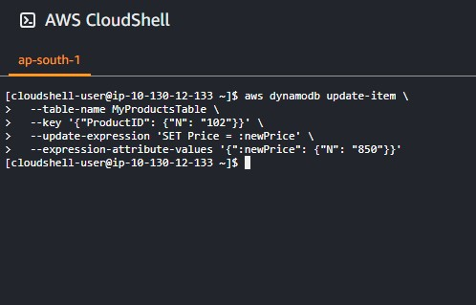

Result: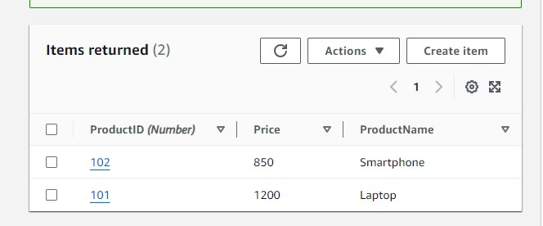

1. Deleting the item from the table. Run the following query

**aws dynamodb delete-item \**

**--table-name MyProductsTable \**

**--key '{"ProductID": {"N": "102"}}'**

this will delete the item with ProductID = 102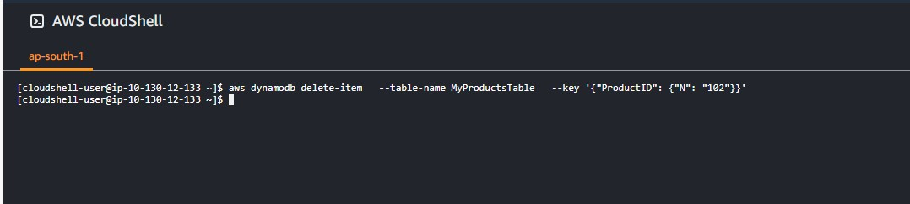

Result: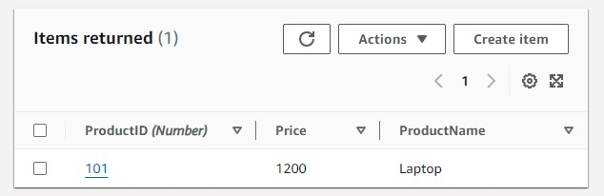

**Now, creating the DynamoDB table through the console:**

1. Search in the console home DynamoDB and go to the DynamoDB console.

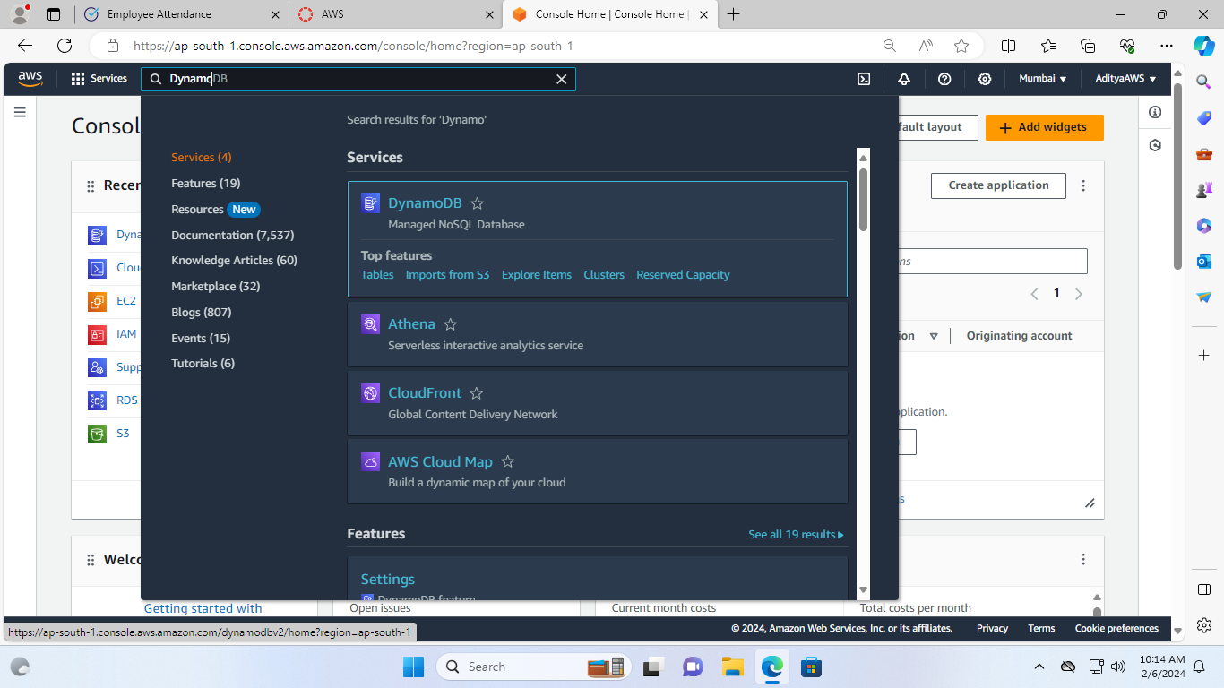

1. Click on “Create table”.

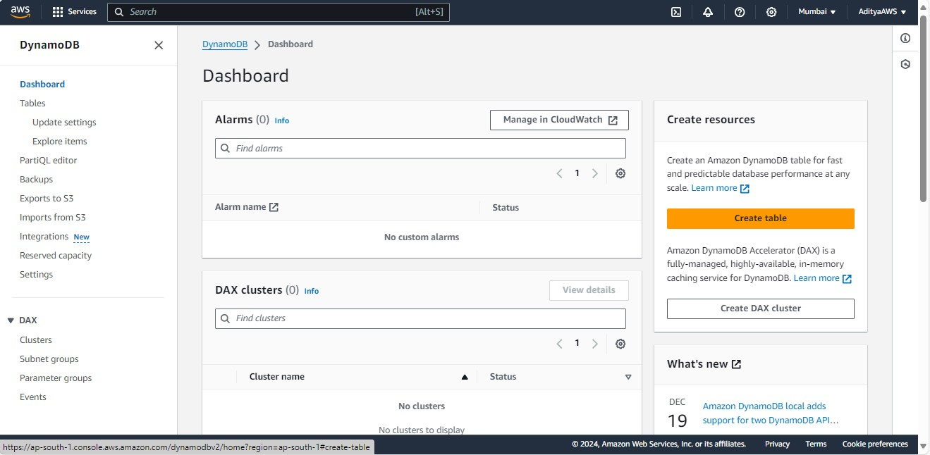

1. Now, fill the table details, add the primary key to the table by filling the partition key also choose the type (Number, String, or Binary).

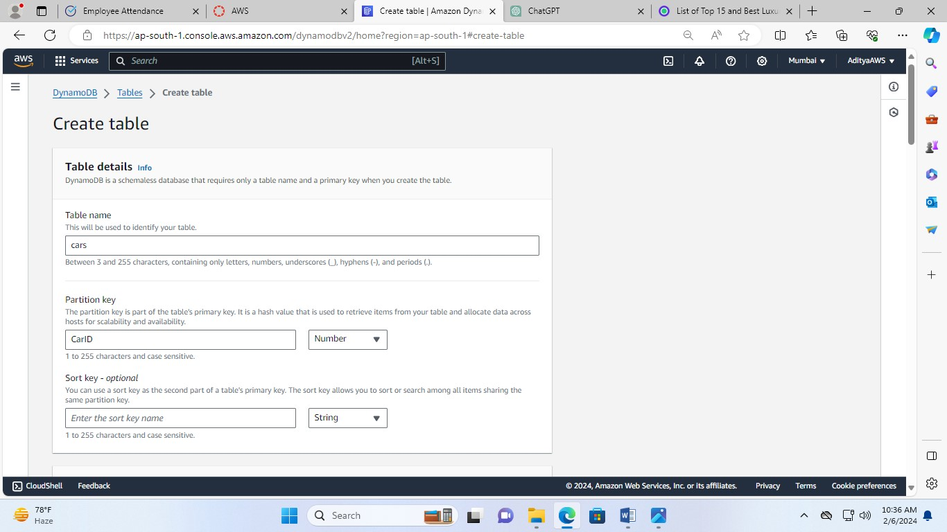

1. Now customize the table settings and define the provisioned throughput.

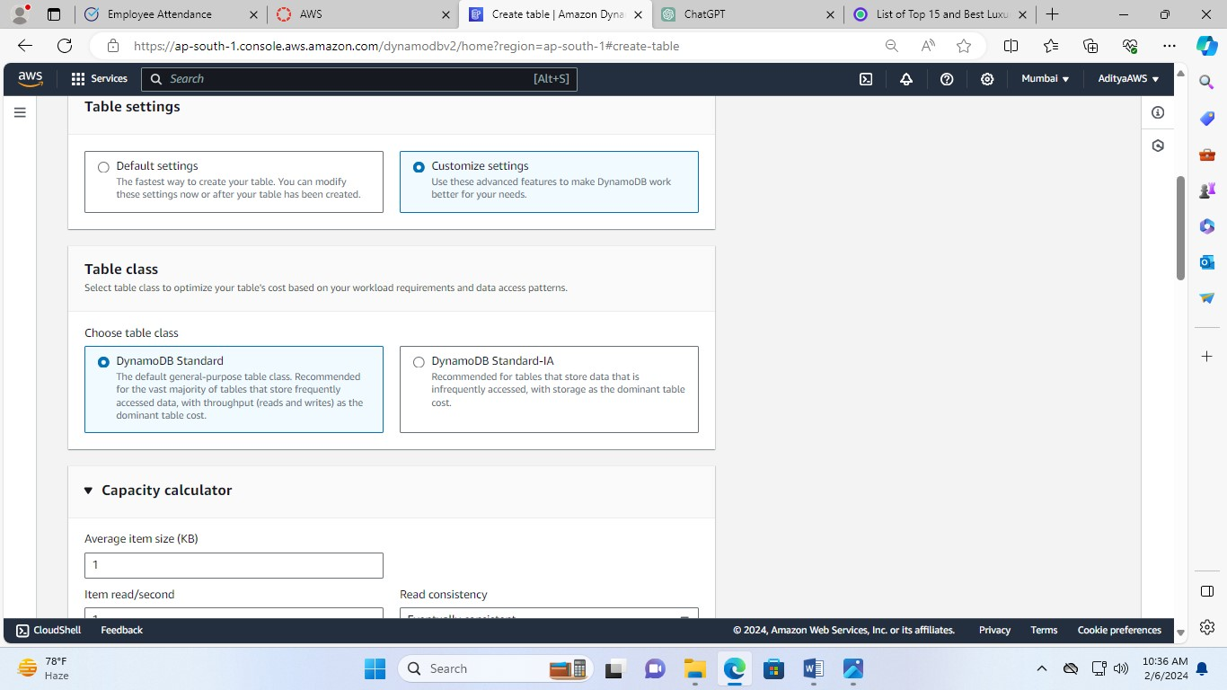

1. Set the read and write capacity settings.

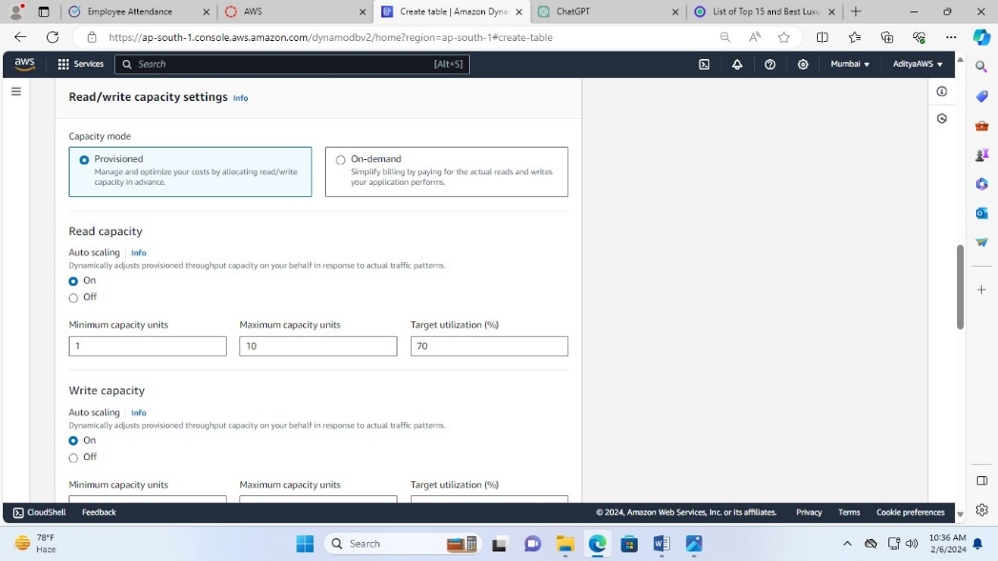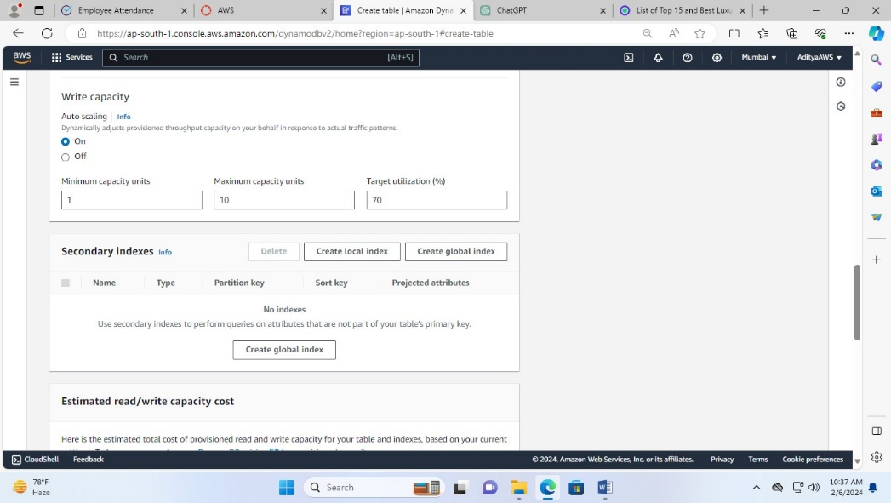

1. Now, click on “Create table”.

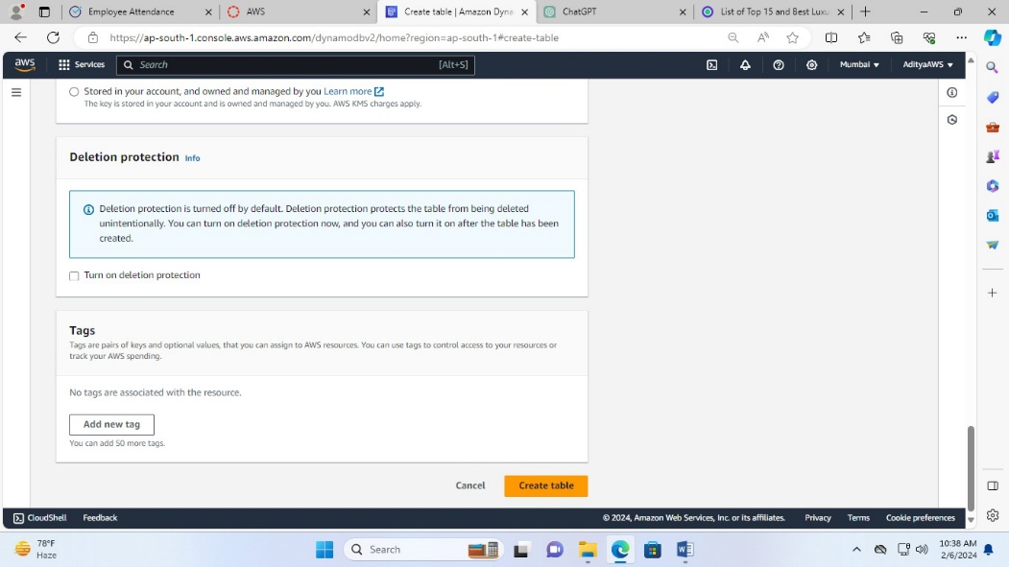

The table has been created successfully.

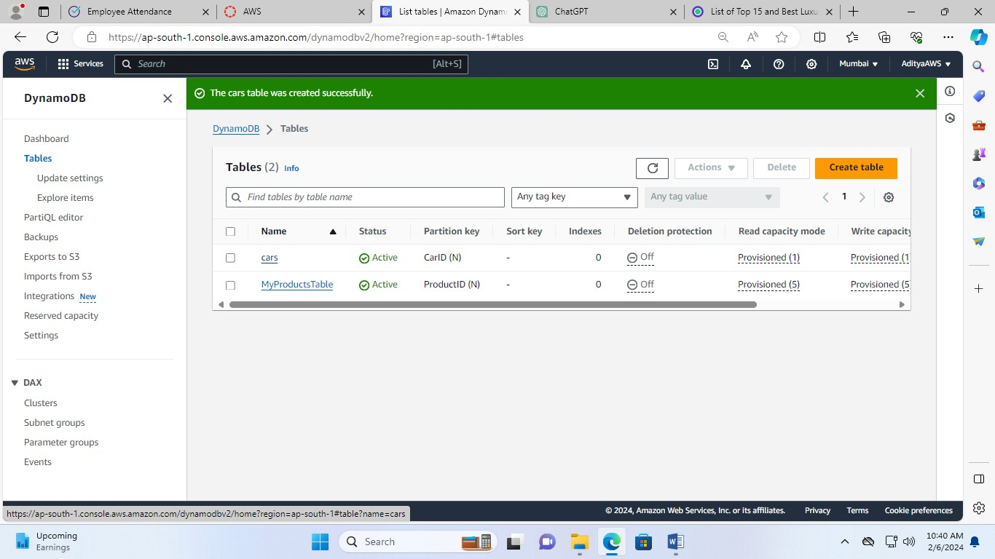

1. Now click on the table and in the actions dropdown click on “Create item” to create item in the table.

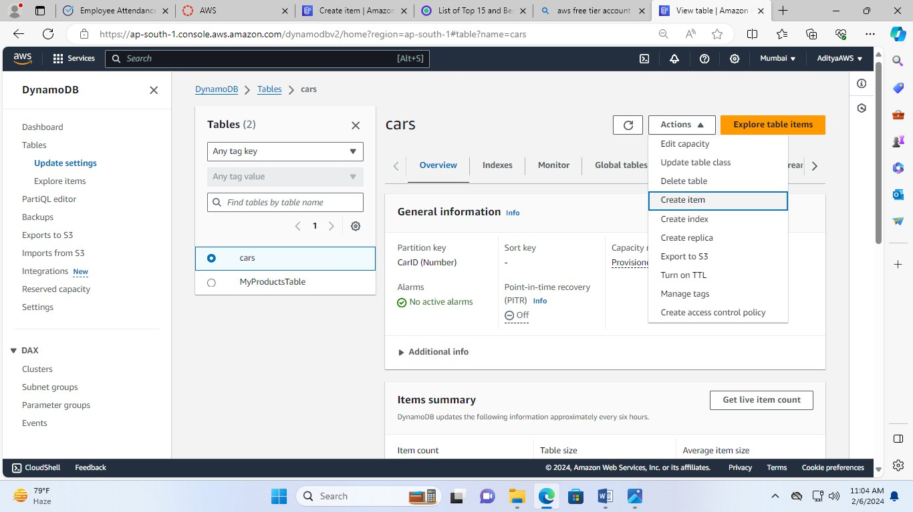

1. Now, add new attributes and add values to them. Click on “Create item”.

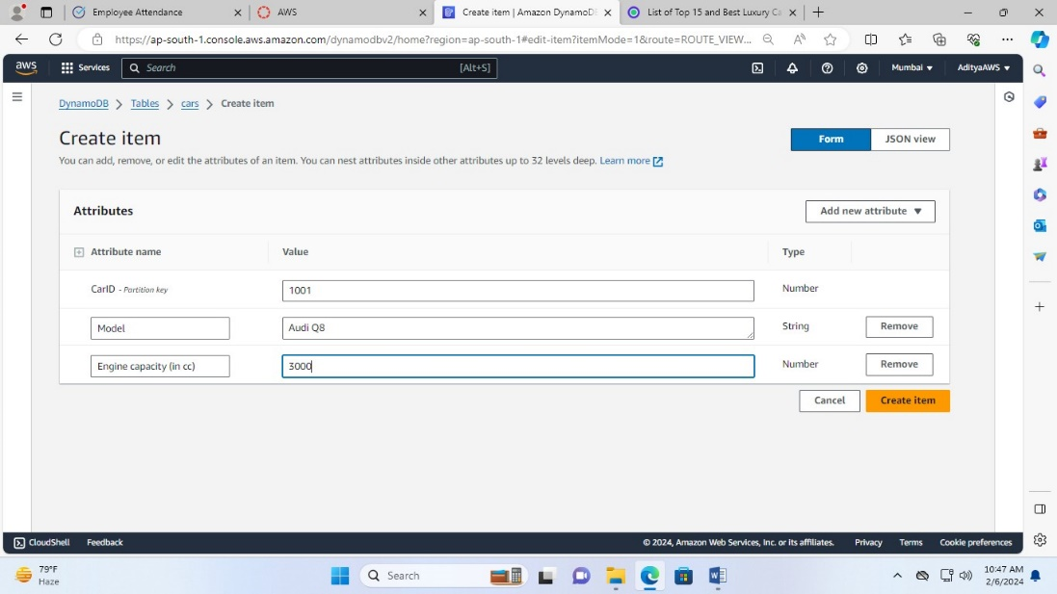

Result:

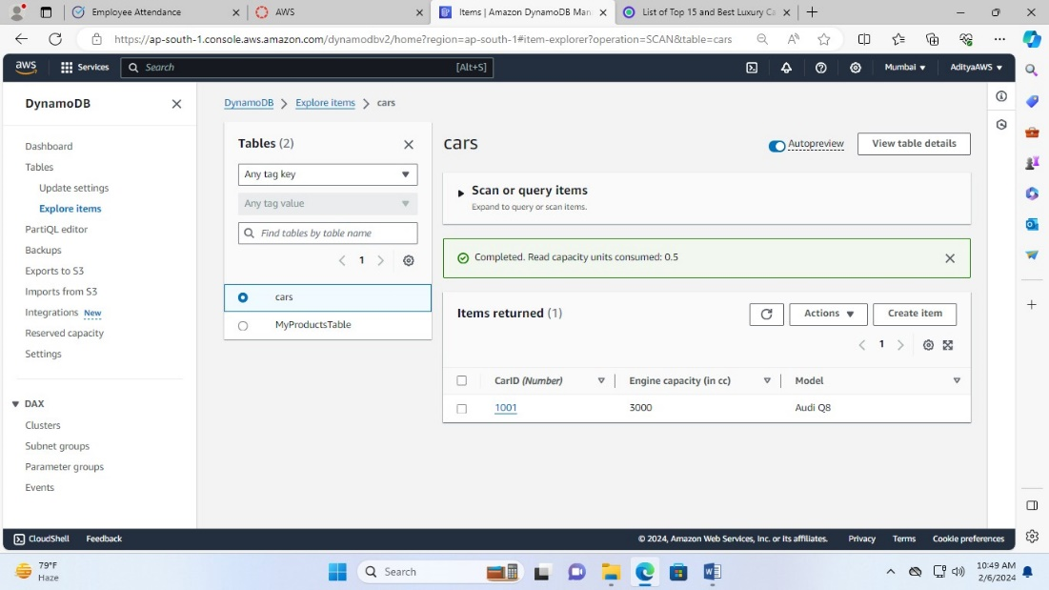

Now, creating item with the JSON view. Switch to JSON view and write the attributes and click on “Create item”.

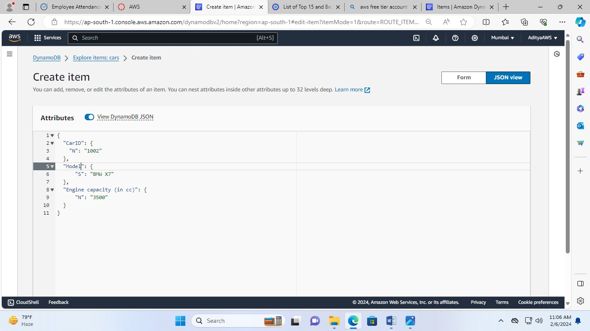

Result:

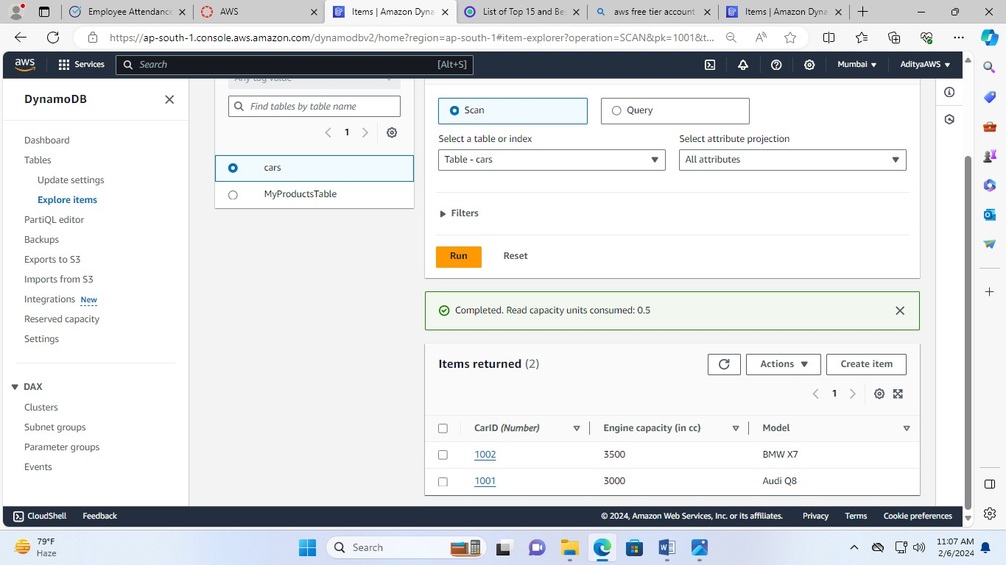

1. Reading the items, go to explore items and switch to query or you can also do it through scan. Now, fill the CarID to see the details of the car. Click on “Run”.

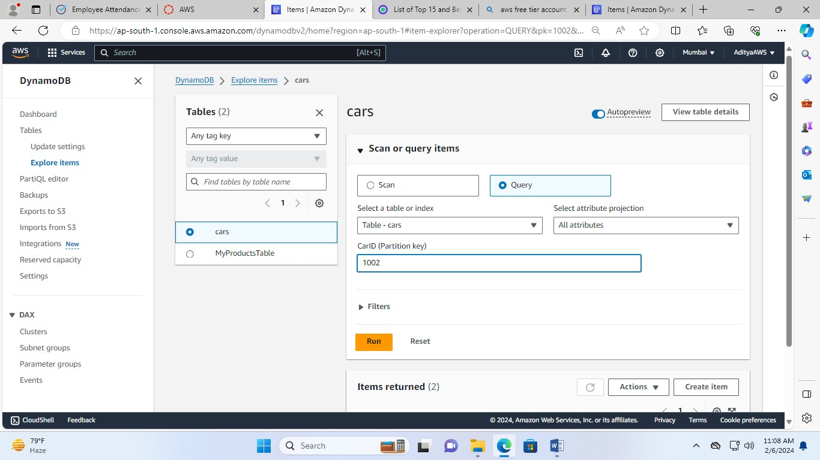

Result:

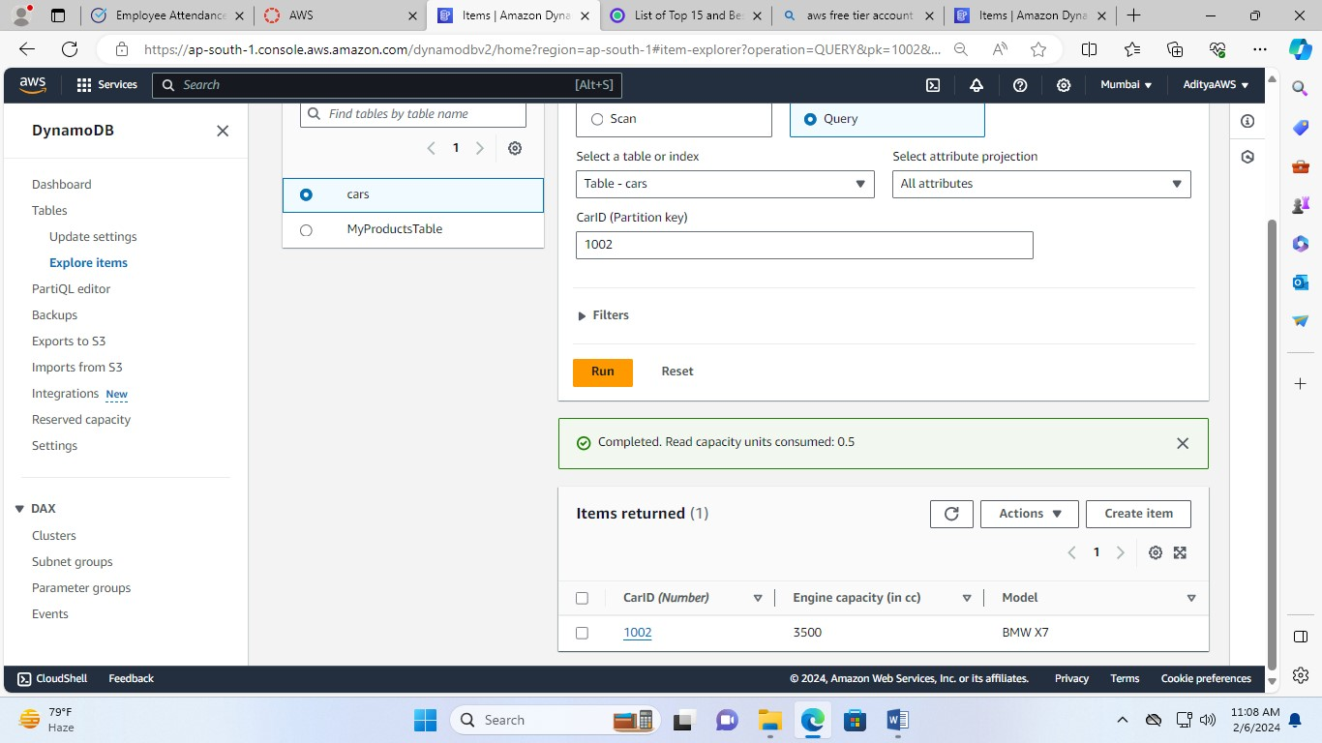

1. Updating the item select the item with CarID=1002 open the actions dropdown and click “Edit items”.

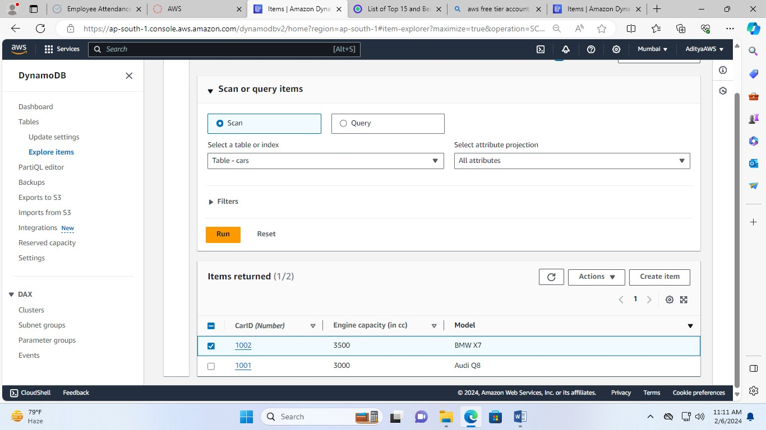

1. Now, edit the Engine capacity value, edit “3500” and fill “3200”. Save the change.

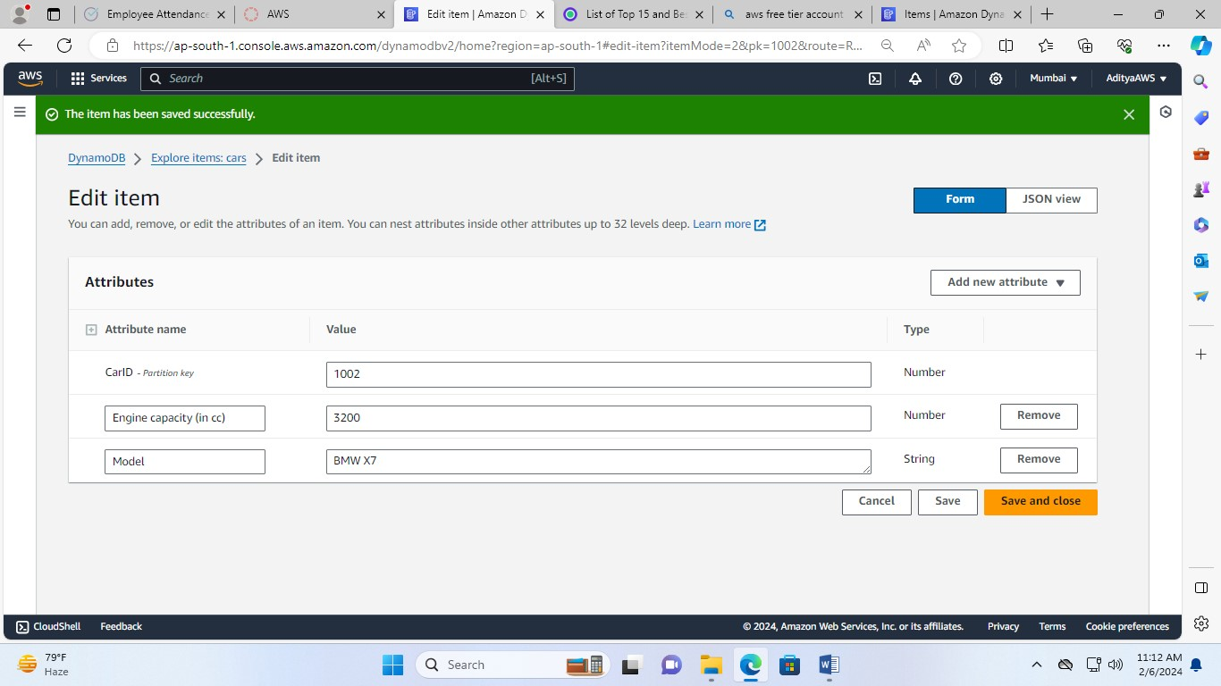

Result:

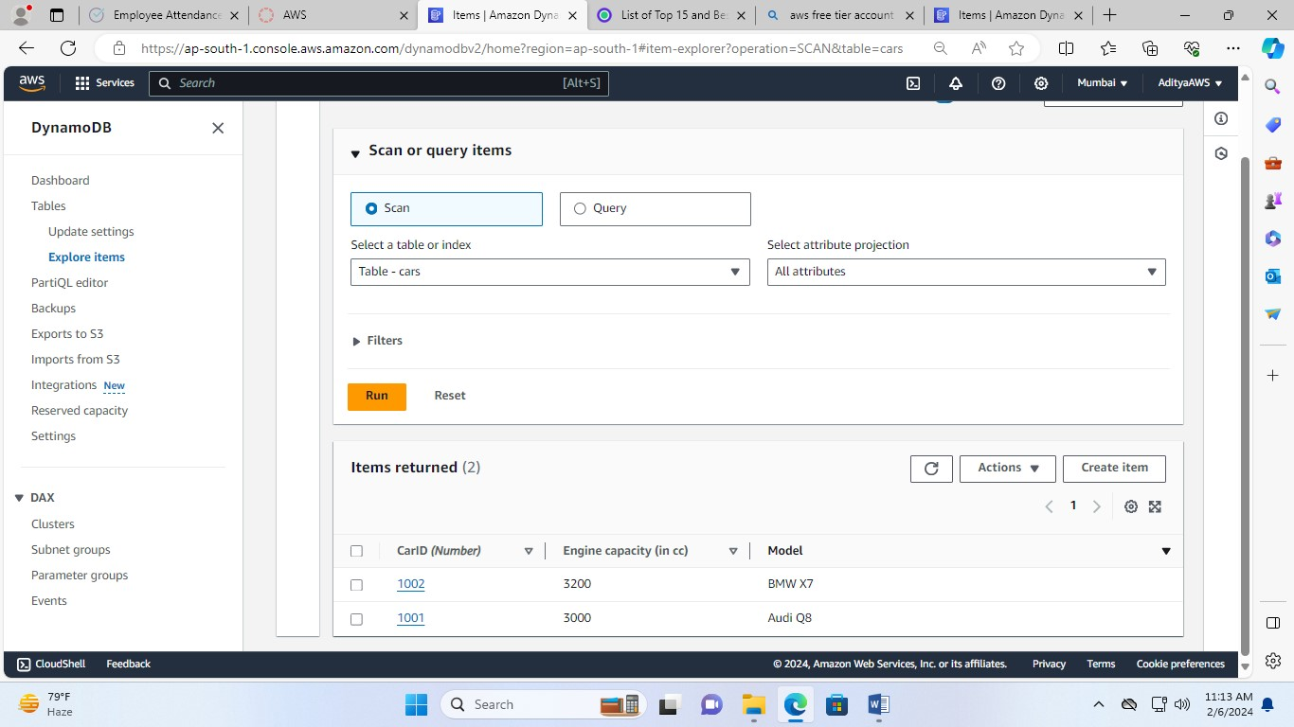

Now, updating the item with CarID=1001 through JSON view repeat the same select the item, go to “Edit item” this time switch to JSON view and edit the engine capacity value. Click on “Save and close”.

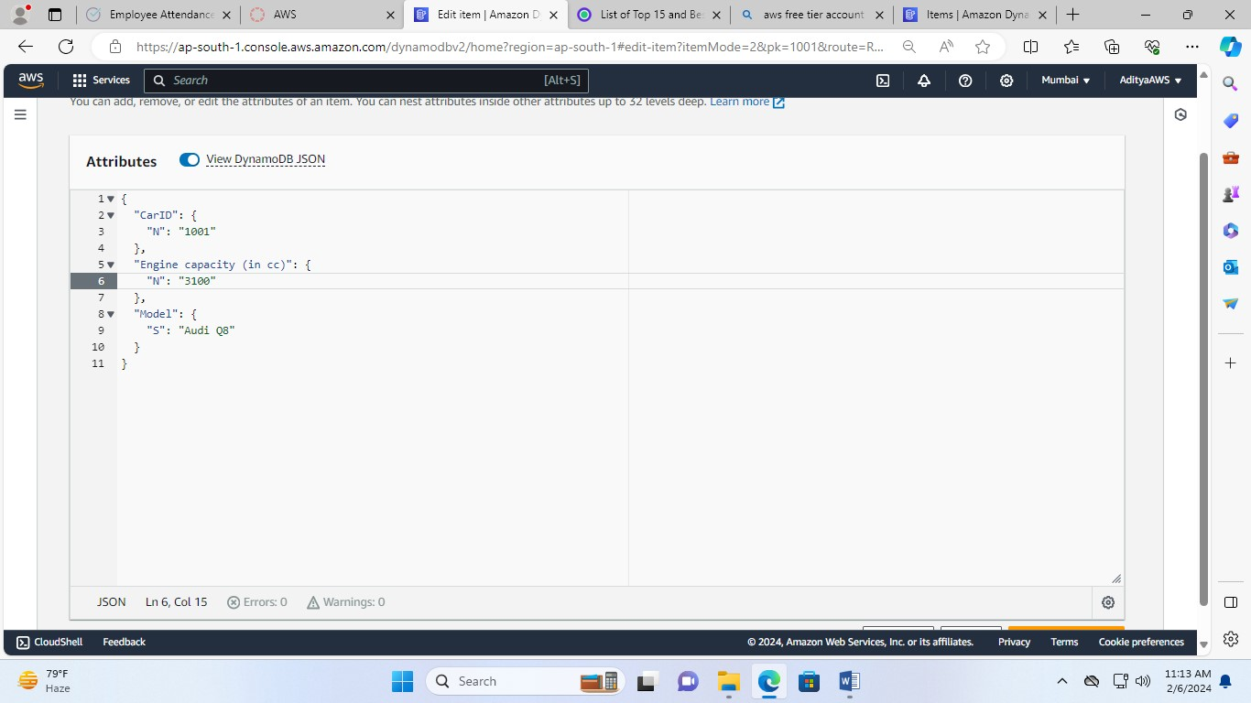

Result: The value of engine capacity of the item with CarID=1001 is now 3100 as it was 3000 at the first time.

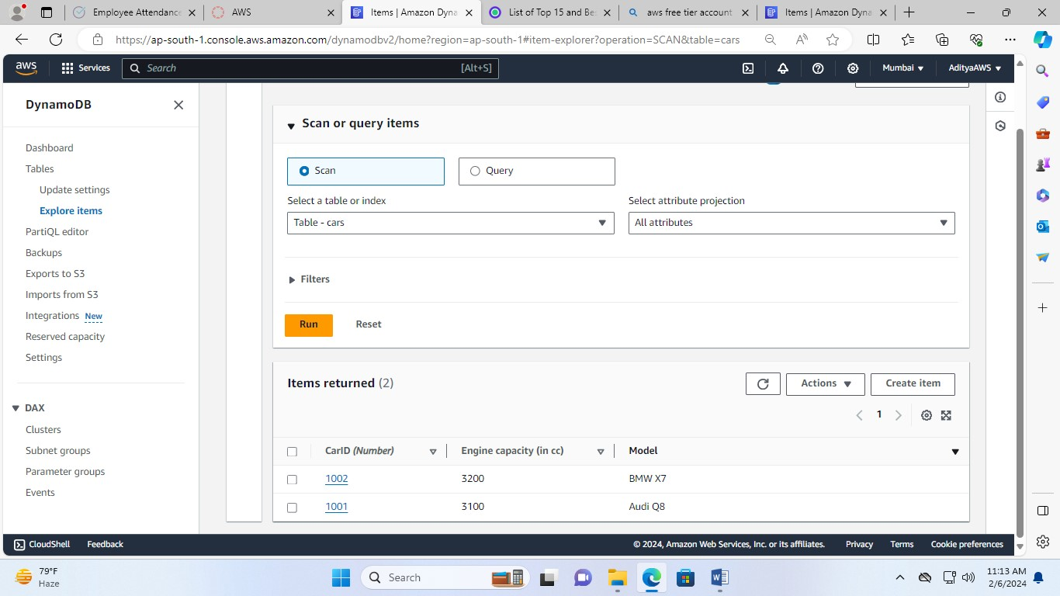

1. Deleting the item with CarID=1002, to delete select the item and open the actions dropdown, click on “Delete items”.

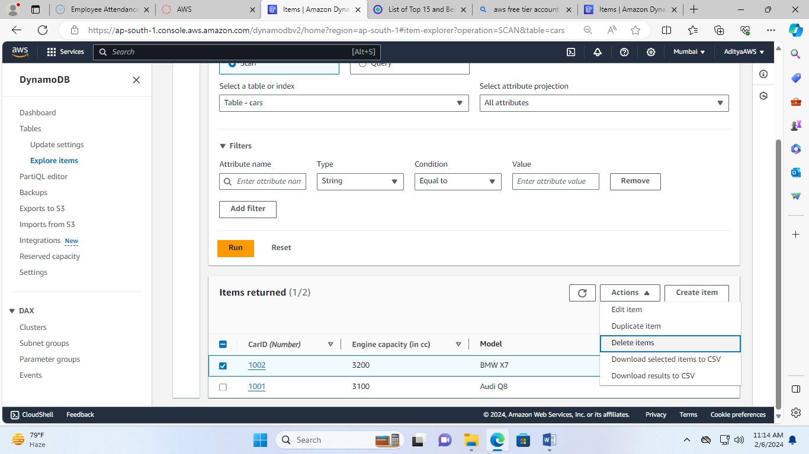

Now, click “Delete”.

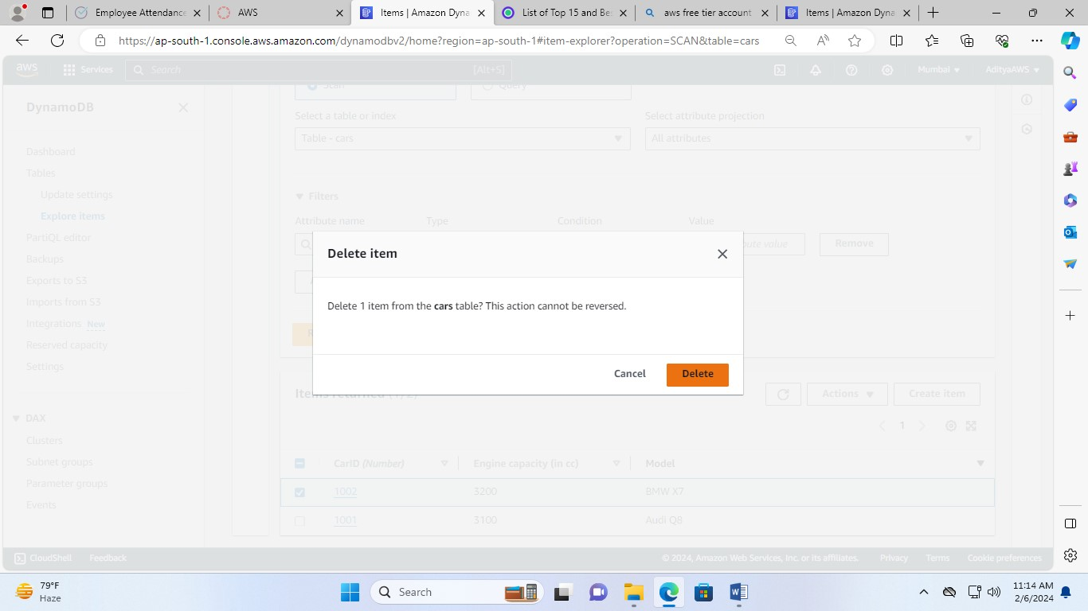

Result:

